Case Report:


Pierre robin syndrome: a case Report

¹Dr. Jigna S. .Shah, ²Yogesh H. Rathva

¹Prof. and Head Of department of Oral Medicine and Radilogy, Govt.Dental College and Hospital Ahmedabad,

²Post Gradguate Student, Oral Medicine And Radiology , Govt.Dental College and Hospital Ahmedabad
QR Code: Scan Here

Corresponding author: Dr Yogesh .h .Rathva
Abstract:
In 1923 Pierre Robin a French stomatologist documented a disorder which now bears his namesake. Pierre robin syndrome Was originally describes as consisting of Micrognathia(which he termed “mandibular hypotrophy) and glossoptosis(an abnormal posterior placement of the tongue) which result in airway obstruction and feeding difficulties,Today we recognize Pierre robin sequence(PRS). Infants with PRS should be evaluated by multidisciplinary team to assess the anatomic finding, delineate the source of airway and feeding issues Positioning will resolve the airway obstruction 70% of cases. In correct position most children will also able to feed normally. if the infant continues to show evidence of desaturation then placement of nasopharyngeal tube is indicated. Early feeding via nasogastric tube may also reduce the amount of energy needed and allow for early weight gain.
INTRODUCTION:
In 1923 Pierre Robin a French stomatologist documented a disorder which now bears his namesake. Pierre robin syndrome Was originally describes as consisting of Micrognathia(which he termed “mandibular hypotrophy) and glossoptosis(an abnormal posterior placement of the tongue) which result in airway obstruction and feeding difficulties[1],Today we recognize Pierre robin sequence(PRS)
Infants with PRS should be evaluated by multidisciplinary team to assess the anatomic finding, delineate the source of airway and feeding issues Positioning will resolve the airway obstruction 70% of cases. In correct position most children will also able to feed normally. if the infant continues to show evidence of desaturation then placement of nasopharyngeal tube is indicated. Early feeding via nasogastric tube may also reduce the amount of energy needed and allow for early weight gain .[1]
CASE REPORT:
A 6‑year‑oldfemale child were broughtby the parents to the outpatient department of oral medicine andradiology with a chief complaint of decayed teeth in upper and lower right and left side posterior teeth region.
On DetailsMedical history of scoliosis and dextrocardia since birth.On respiratory system examination,cardiovascular examination ,Opthalmological examination are found normal
No family history reported and she was first birth order with no siblings.
On general examination conscious,co-operative,short slature,poor built,asymmetry on right side of face,,deform ear also noted on right side (figure 1,4)
On careful Examination of patient we observe extraorally facial asymmetry on right side of face show receded chin,lowset ears, and convex profile characteristic resembling bird face appearance,deviation of spine on left side its suggestive of scoliosis and on intraorally high arched U shaped palate, deviation of mandible on right side face,grossly carious teeth,ankyloglossia,absence of condyle,coronoid process,and posterior body of ramus(figure 2,3)
On radiographic examination
IOPA shows maxillary right posterior tooth region deciduous 2ndmolar permanent 1st molar show radiolucency involving enamel dentin and approaching toward pulp is seen distal aspect of maxillary 1st molar its suggestive of carious lesio
OPG shows mixed dentition and also loss of mandibular right ramus with condyle,coronoid process its suggestive of partial agnathia of mandibular right ramus ,coronoid process(Figure 5)
CT SCAN shows deviation of mandible toward right side within body of ramus,coronoid, condyle process, atrophy of external auditory canal also seen on right side,and a single well defineisodense area seen in left maxillary sinus extending anterio-posteriorly lateralwall is sinus to medial wall of sinus and sup inf floor of maxillary sinus to 1cm to superiorly to its suggestive of mucosal thickeningZygomatic arch on rightside appear to shorter as compare to left side(Figure 6)
Chest x-ray shows mild scoliotic deformity with convexity toward rightside(Figure 7)
2D Echo cardiogram shows situs increase dextrocardia and mild TR
Hemogram shows increase platelets Count,decrease plateletcount,IncreaseRBC,DecreaseHematocrit MCV.MCH,MCHG
RFT shows decrease serum creatinine and bilirubin also bilirubin also decrease
2D Echo cardiogram shows situs increase dextrocardia and mild TR
Restoration of carious tooth i.r.t 16 was done
Considering above finding consulted oral surgeon and prosthodontist to plan for artificial prosthesis for condyle ,coronoid and ramus of mandible as well as ear. Patient is under follow up for same.

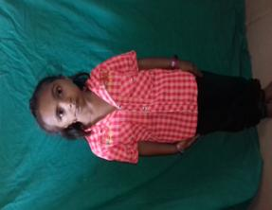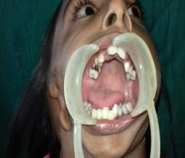

Figure 1 figure 1shows short stature Figure 2 shows high arched palate,carious tooth ,malalign tooth and deviate mandible
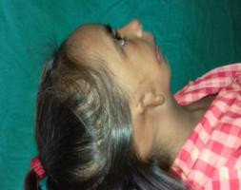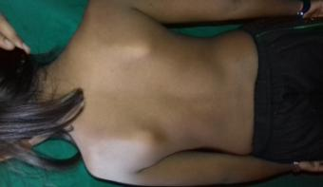
Figure 3 shows micrognathia and ear deformitiy Figure 4 shows scoliosis

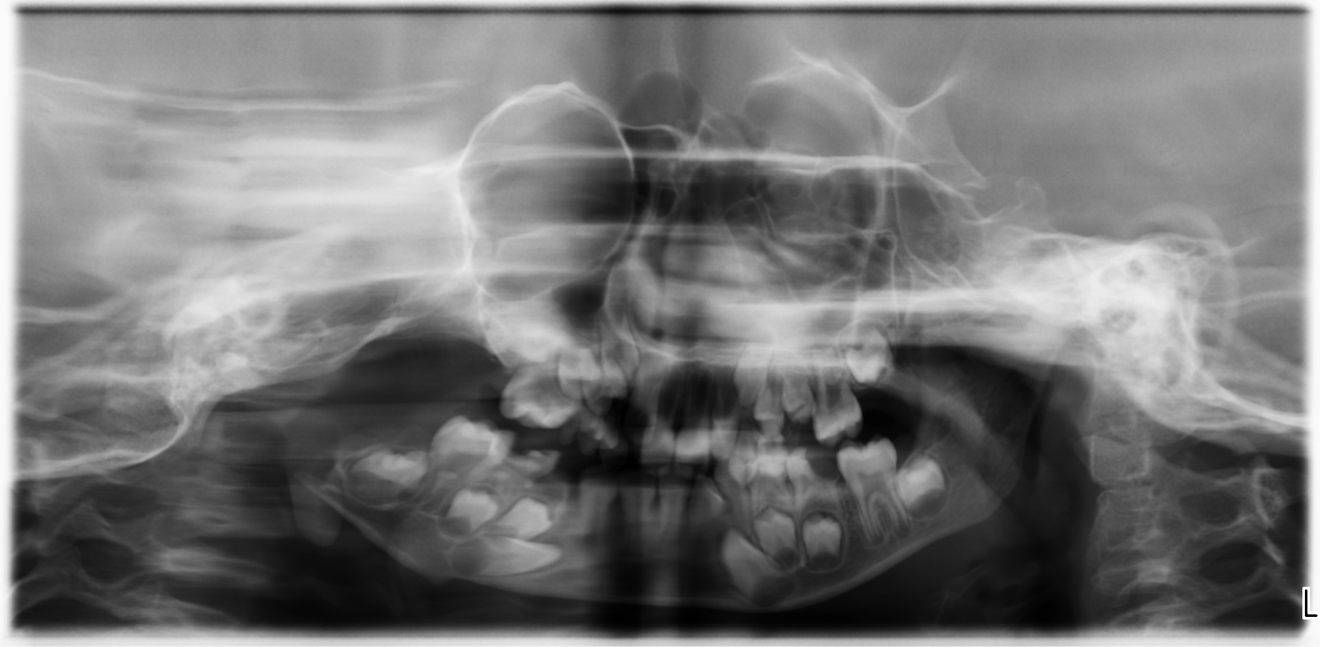
Figure 5 shows absence posterior body of mandible (right side)condyle ,coronoid process

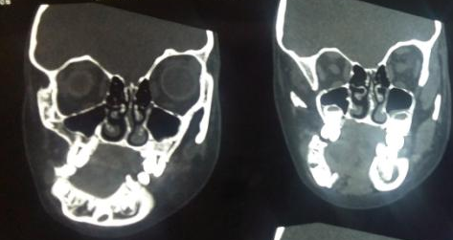
Figure 6: shows absence of condyle ,coronoid and posterior body of mandible(right) and deviation mandible toward right side
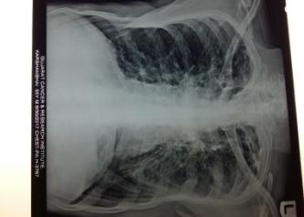

Figure 7: shows scoliosis

DISCUSSION:
Pierre robin syndrome patient we observed our patient extraorally facial asymmetry on right side of face show receded chin,lowset ears, and convex profile characteristic resembling bird face appearance,deviation of spine on left side its suggestive of scoliosis and on intraorally high arched U shaped cleft palate, deviation of mandible on right side face,grossly carious teeth,ankyloglossia,absence of condyle,coronoid process,and posterior body of ramus
Three pathophysiological theories exist to explain the occurrence of micrognathia:
The mechanical theory, which is the most accepted postulate that thein utero constraint of mandibular
growth results in failure of descent of tongue whichfurther prevents fusion of palatal shelves resulting ina cleft palate. The neurological maturation theory that suggestsby the inability of the developing fetus to engagein mandibular exercise prevents the tongue fromdescending. The dysregulation theory or the motor and regulatoryorganization of the rhombencephalon is related tomajor problem of ontogenesis[.4] Pierre Robin sequence is related to several other craniofacial anomalies and may appear in conjunction with the findings characteristic of several different syndromes. Stickler syndrome, an autosomal dominant condition, is characterized by a short mandibula ramus, antegonial notching of the mandibularbody, myopia, and joint problems. Velocardiofacialsyndrome is characterized by a retrognathicmandible, palatalabnormalities ,hypotonia, Impaired thymus development,and cardiac malformations.[6]
Management:
Nonsurgical Management
Prone or lateral positioning will solve the airway obstruction _70% of cases of PRS.With appropriate positions, manyof these children will also be able to feed normally and no further treatment is necessary. If the baby continues to showevidence of desaturation, then placement of a nasopharyngeal(NP) tube is indicated, where the aim of the tubeplacement is to bypass the site of upper airway obstruction. Chang et al have discussed the technique of creatingindividualized NP tubes from endotracheal tubes, with thediameter and length chosen according to the infant’sweight[1]
Tongue–Lip Adhesion
Tongue–lip adhesion (TLA) was first described by Shukowskyin 1911 and popularized by Douglas in the mid-20th century.18 The procedure serves to correct the problem of glossoptosisby pulling the base of the tongue forward andsuturing it to the lower lip. [14]
Distraction Osteogenesis of the Mandible
Distraction osteogenesis (DO) of the mandible, first describedin 1989 by McCarthy, has become popular as the definitivetechnique to address the issues associated with PRS by relieving airway obstruction, improving facial cosmesis, and correctingmalocclusion.The process of mandibular distractionlengthens the jaw in a forward direction, and also indirectly pull tonguebase anteriorly. As the mandible is projectedforward, the tongue is also pulled anteriorly through itsmuscular attachments on the lingual surface of the mandible.Thus, this technique reverses the sequence of PRS by correctingthe micrognathia, which in turn improves the glossoptosis,thereby relieving the obstruction of the airway.[1]
CONCLUSION:
Clinicians must be aware of the fact that Pierre Robinsequence can be associated with a large number ofsyndromes.

REFERENCES:

1. Pierre Robin Sequence, Noopur Gangopadhyay, Derick A. Mendonca, seminar plastic surgeon , 2012
2. Siblings with Pierre Robin sequence , Medhini Madi, Subhas G. Babu, Sonika Achalli, Supriya Bhat, Kumuda Rao Journal of health and reaseach , 2017
3.Pierre Robin syndrome: casereport , Richa Gupta1*, Meena Patel2, Naresh BajajInternational journal of research in medical science November 3, 2015
4 .Pierre robin sequence: Report of two cases , Hegde RJ, Mathrawala NR1 Journal of Indian society of pedodontics and preventive dentistry oct-dec 2010
5.First-trimester diagnosis of micrognathia as a presentationof Pierre Robin syndrome , M. TEOH* and S. MEAGHER†ISOUG 2003
6.Pierre Robin Sequence report, the relevance of autopsy Cristiano C. Oliveira; Maria Aparecida C.2015
7:A Pierre Robin Syndrome with Absent Anterior 2/3 Tongue—A Case Report , Surender1, K. Vasudev1, B. Balaram1, C. H. Vijay Raj1, Lingaiah Jadi2 Internatinal journal of otolaryngology and Head and neck surgery,2015
8 Incidence of the Robin Anomalad (Pierre Robin syndrome) , P. G. BUSH and A. J. WILLIAMSMersey Regional Cleft Palate Unit, Liverpool (Alder Hey Children’s Hospital, Liverpool: Royal LiverpoolBritishjounal of plastic surgery(1983)36
9.Pierre Robin sequence: appearances and 25 years of experience with an innovative treatment protocol Kurt-W. Bütowa,⁎, Christiaan Frederik Hoogendijk a, Roger A. Zwahlen b Journal of pediatric surgery(2009)44
10.The mandibular catch-up growth controversy in Pierre Robin sequenceJohn Daskalogiannakis, DDS, MSc,aR. Bruce Ross, DDS, MSc,band Bryan D. Tompson, DDS, Dip OrthocToronto, Ontario, Canada American journal of orthodontics and Dentofacial orthopedics 35:668-670
11.A rudimentary epiglottis associated with Pierre Robin sequence , S.-P. Li, T.-J. Fang, S.-W. Lee, H.-Y. Li: A rudimentary epiglottis associated withPierre Robin sequence.Int. J. Oral Maxillofac. Surg. 2006; 35: 668–670. # 2006
12.piere robin and the syndrome that Bears his namesake , Presented convention of American cleft palate associan los angles california
13 .Hereditary factors in the pierre robin syndrome danniel m.d, fb caroll .a.c,s, rex a. peterson m.d f.a.c.s ,eugane w. worton, m.d and lawerence m birnbaum md arizona crippled children hospital phoenix arizona U.S.ABritish jounal of plastic surgery
14.Pierre Robin Sequence in a Neonate With Suckling Difficulty and Weight Loss , Jeffery Summers, OMS IVJacob Ludwig, OMS IVDavid Kanze, DOI
15 .Quality of life in children with Robin Sequence ,Karolijn Dulfer a,b,*, Manouk J.S. van LieshoutInternational jounal of pediatric otorhinolaryngology 86 2016

